Task 2 – System Designs

A) Process Flow
The simulation is a sequential, multi-stage queueing system with shared service pools and probabilistic inspection branching.

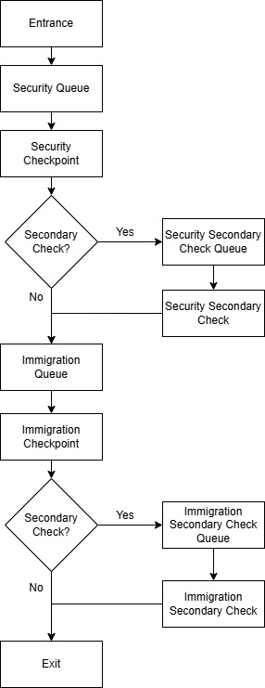
Flow Summary & Key Rules
- Travellers progress sequentially through Security → Immigration → Exit
- Each stage uses FCFS queues (shared or dedicated) that feed into shared service counters
- Service counters operate as shared pools, assigning the next available traveller from queues
- Secondary inspections are triggered probabilistically and depend on traveller attributes (e.g. risk, baggage, document readiness)
- Secondary checks are handled in separate processing areas with longer service times
- The system enforces a strictly forward-moving flow with no backtracking or stage re-entry
- Completion of Security is mandatory before entering Immigration

B) System Components
- Travellers (Agents)
    - Individuals moving through the checkpoint system
    - Attributes: traveller type, risk level, baggage count, document readiness
    - Influences processing time and secondary inspection probability
    - Traveller attributes are generated using scenario-based probability distributions to simulate different operational environments:
      - Default (baseline conditions)
      - Holiday (high passenger volume, slower movement)
      - High Risk (increased inspection likelihood and variability)

Attribute | Default Scenario | Holiday Scenario | High Risk Scenario
Move Speed | 5 – 20 | 5 – 8 | 10 – 16
Baggage Count | 1 – 3 | 2 – 5 | 1 – 3
Document Readiness | 0.7 – 1.0 | 0.5 – 1.0 | 0.0 – 1.0
Traveller Type | 50% Leisure  40% Business  10% VIP | 70% Leisure  20% Business  10% VIP | 70% Leisure  20% Business  10% VIP
Risk Profile | 70% Low  20% Medium  10% High | 70% Low  20% Medium  10% High | 40% Low  35% Medium  25% High

- Queue System
The system uses two queueing models depending on stage type.
a) Ordered Queues (Security & Immigration)
    - FCFS queues with slot-based capacity
    - Travellers wait in a holding area if no slot is available
b) Simple Queues (Secondary Check Areas)
    - Unordered queues with flexible entry
    - Used for secondary inspection processing
- Service Counters
    - Security counters (primary screening)
    - Immigration counters (primary clearance)
    - Secondary inspection counters for each area (lower capacity, slower processing)
    - Stations are generated using a configurable grid system (Rows × Columns)
    - Each area (Security, Immigration, Secondary) supports dynamic station scaling at runtime

- Scenario Manager
    - Controls scenario presets and global simulation configuration including staffing, queue layout, processing rules, and secondary inspection modifiers

- Metrics System
    - Tracks wait times, queue lengths, throughput, utilisation, and bottlenecks
- Simulation Engine
    - Manages time progression, spawning, queue flow, service processing, and metric updates

- Runtime Configuration System
    - Centralised parameter system controlling world generation and simulation behaviour
    - Supports runtime modification of:
      - Station layouts
      - Processing time modifiers
      - Secondary inspection probabilities
      - Queue configurations
C) Input Parameters
- Simulation Control
    - Random seed (controls reproducibility)
    - Simulation speed (time scaling factor)
    - Scenario presets define global simulation behaviour by modifying traveller attribute distributions and system load characteristics

- Demand Configuration
    - Agent arrival rate (number of travellers per second)
- System Capacity
    - Station configurations for each area (grid-based dynamic scaling)
    - Active stations for each area (enable/disable counters)
- Secondary Inspection Control
    - Secondary check probability modifier (security)
    - Secondary check probability modifier (immigration)

D) Simulation Outputs
- System Overview (Key Performance Indicators)
    - Simulation time (runtime progress)
    - Active travellers (current system load)
    - Total travellers processed (throughput volume)
    - Overall throughput (travellers per minute)
    - Average total time in system (end-to-end performance)
    - Current bottleneck location (Security / Immigration / Secondary)
- Flow Throughput (System Capacity Analysis)
    - Security throughput rate
    - Immigration throughput rate
    - End-to-end system throughput rate
- Queue Performance (Congestion Analysis)
For Security & Immigration Queues:
    - Current queue length
    - Average queue length
    - Peak queue length
    - Average waiting time
- Secondary Inspection Analytics (Constraint Pressure Points)
For Security Secondary / Immigration Secondary Check Areas:
    - Secondary queue length
    - Average waiting time
    - Average processing time
    - Secondary check rate (%)
- Resource Utilisation (Staff Efficiency)
For all station areas
    - Average utilisation (%)
    - Idle counters
    - Average processing time
- Bottleneck Analysis
The system automatically identifies the bottleneck location based on highest average waiting time.
    - Security
    - Immigration
    - Security Secondary
    - Immigration Secondary
    - No significant bottleneck (if below threshold)

E) Assumptions
- Process Based Assumptions
    - All travellers must complete Security before proceeding to Immigration
    - Processing stages are strictly sequential
    - No backtracking or re-entry to previous stages
- Queue Behaviour
    - Ordered queues operate on FCFS discipline with slot-based capacity
    - Travellers may wait in a holding area if no queue slot is available
    - Secondary inspection areas use simple, unordered queueing structures
    - No queue jumping or overtaking occurs
- Service Based Assumptions
    - Each counter processes one traveller at a time
    - Service times are stochastic and influenced by traveller attributes
    - Secondary inspections take longer and are more variable than primary processing
- Behavioural Assumptions
    - Travellers do not exhibit impatience or abandon queues
    - Movement between stages is instantaneous after service completion
    - Traveller attributes remain constant throughout the simulation
- System Based Assumptions
    - Counters are always available when idle (no breakdowns or downtime)
    - Secondary inspection probability is determined at point of entry to each stage
    - Random seed ensures reproducible simulation runs when enabled
- Scope Based Assumptions
    - The model prioritises queueing and operational performance over physical crowd realism
    - Agent movement is abstracted into system-level transitions
    - The simulation is intended for performance analysis, not behavioural crowd modelling

